Airheads 2021 Missouri Rolling Rally
You are invited to the 2021 Missouri Rolling Rally!!! If the phrase “Rolling Rally” just sounds like another way to get a group of cheapskates with old Airheads together and ride across the country…then you should probably join us. 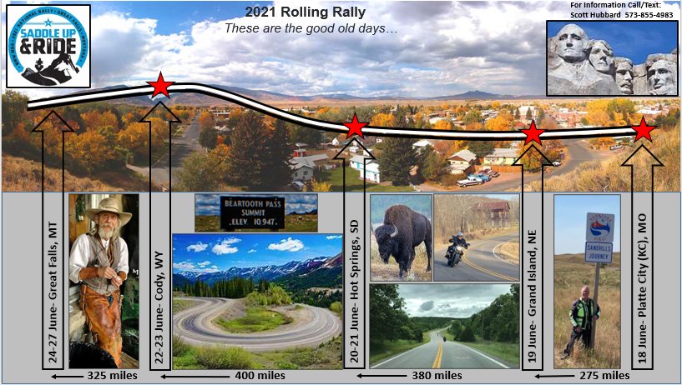
If you feel like this is too much information and you would like less, feel free to call or text me anytime: Scott Hubbard 573-855-4983.
It’s all in the details…or the lack of: After a successful inaugural run to the 2019 BMW MOA National Rally in Nashville, the Missouri Rolling Rally is back. The 2021 BMW MOA National Rally is 24-27 June in Great Falls, MT-The Missouri Rolling Rally is a “non-planned”, “non-event” that will map out a “loose” route from the Missouri to the BMW National Rally in Great Falls. We also hope others rendezvous in other parts of the country, and if you’re coming from the east side of the country, consider funneling in to Missouri to join us.
The Route: Exactly how “loose” is the route? Well, the planning committee voted unanimously to head “West”, everything after that was a spit 50/50 tie so we will leave that up to each rider. What we did manage to lock in each night’s camping locations by dates. When you look at these dates/stops, remember that everything was planned “backwards” to provide flexibility for individual schedules while still placing us all in Great Falls, MT on the start day of Thursday, 24 June.
So what if a rider really, really wants to detour from the route and ride that very special road or maybe stop by Aunt Nellie’s in Crossroads, WY to pet their favorite chicken??? Sounds great- They can catch up with the group later in Cody or Great Falls. There will be no hard feeling. This isn’t like “unfriending” someone on social media…it’s expected that riders will break off and join up as we ride. It’s your ride- Make it what YOU want!
So why even do this then? Very simple- Because nostalgia is cool, but reality isn’t…Airheads can break down and it usually takes a combination of knowledge, tools and parts to fix them. This route ensures everything you should need to make it a reality. You see, each night’s camping location is conveniently located at/near an Airhead member’s home along the route. Brilliant!!!
Platte City, MO Mark Nelson (Home of ABC Platte City Tech Days), 13380 State Highway N, Platte City, MO. What can I say about Mark? No…seriously, what can I say about Mark…Oh yah- I’ve never left there hungry!! Mark has a great shop for any quick repair needed. We will be starting the ride from Mark’s home Saturday morning for a leisurely 275 miles. Eastern travelers can show up Friday night to camp in the yard, locals can show up Saturday morning or just catch us on the route to Grand Island.
Grand Island, NE Camping at the Grand Island KOA: https://koa.com/campgrounds/grand-island/ which is about a mile or so from John Wayne’s home (Not that John Wayne-Former NE Air Marshal), 1101 Nebraska Highway 2, Phillips, NE. John usually pushes an Airhead out by the road to mark his driveway. He has a great shop for repairs with a few of his personal Airheads. We will figure out a dinner plan, but I heard the KOA has hot pizza. We will head out Sunday morning for the 380 mile ride through the Nebraska Sand Hills.
Hot Springs, SD Camping at the home of Jeff Ecker (SD Air Marshal/International man of mystery), 245 North 5th Street, Hot Springs, SD (phone 605-890-2615). Jeff is so cool, he is allowed to touch the art at the museum! We rode to his SD Tech Day last fall and enjoyed the very best in Airhead riding and hospitality. He guided us on rides through the Black Hills and even took us all into town for a dip in the creek. Jeff is simply an exceptional host and literally opened his shop, yard and home to us all. We have scheduled two days here because there is so much to see including Mount Rushmore. If you are leaving later or trying to catch up with the group, you can do it here since we have an extra day built in. We will leave Tuesday morning for the 400 mile trip. There are multiple routes to choose from so take your pick.
Cody, WY Camping at Cody KOA https://koa.com/campgrounds/cody/ or any number of other local spots in town. Tony Lehman (Former Air Marshal and ABC Tool Loan guy), 1841 Lane 12, Powell, WY. Tony has some tools and a garage for repairs. Also, Bob’s Motor Works in MT is about an hour away for needed parts. We expect to go into Cody for dinner where you can still get a bison burger and watch a gunfight!!! We have scheduled two days here because there is so much to see including Beartooth Pass, Yellowstone, a museum and all the beautiful sites in downtown Cody. If you are leaving later or trying to catch up with the group, you can do it here since we have an extra day built in. We will leave Thursday morning for the 325 mile trip. There are a number epic routes to choose from so take your pick.
Great Falls, WY ABC Airheads Tent (Unsolicited knowledge, tools, parts and food). https://rally.bmwmoa.org/
Sunday morning at the Rally is the same every year as the Rally is empty by noon- Every man for himself so have a safe trip home!
What the Rolling Rally is: When you attend a Rally everyone generally wakes up and discusses their individual plans for the day. Some folks take it easy and some get adventurous and pile on the miles seeing epic sites. At the end of each day, everyone ends up back at the Rally discussing their version of the day’s adventure. That’s what we will do- The difference is that we will join up at different campsites along the trip. Each rider is welcome to join in whenever and wherever they would like and take different routes to the next day’s camping location.
What a Rolling Rally is NOT: It is not an Airport- You don’t really need to announce your arrival and departure. If you don’t like the route, camping or food, then you can change it as you and your riding partners like. But, If you are heading West during these dates, it will be great to see you.
Is it an “Airhead event”? I’d say it is an “Airhead sponsored” event and we should all feel great about inviting folks along to see how we BMW riders do it. Airheads have been “Piggy backing” of the BMW Rallies, and other bike events for years so it would be nice for us to be just as welcoming.
Make your plans and invite your friends. We hope to see you somewhere along the route on the 2021 Rolling Rally!!!
These are the good old days and the opportunity for a “Remember when…” story.

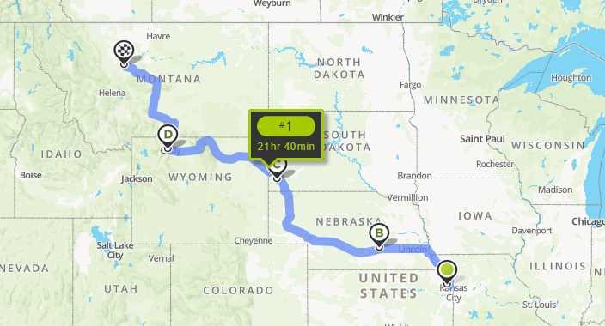

Unfortunately, we can expect Nebraska A/M Mike Quinn to join us here. Apparently, his wife read the Airmail and saw there was a two week trip she could send him on so she could get some peace and quiet- Can’t blame her!!! I see she has already packed up his bike. Wink, wink…I never miss a chance to get a cheap shot in on Mike!!!
