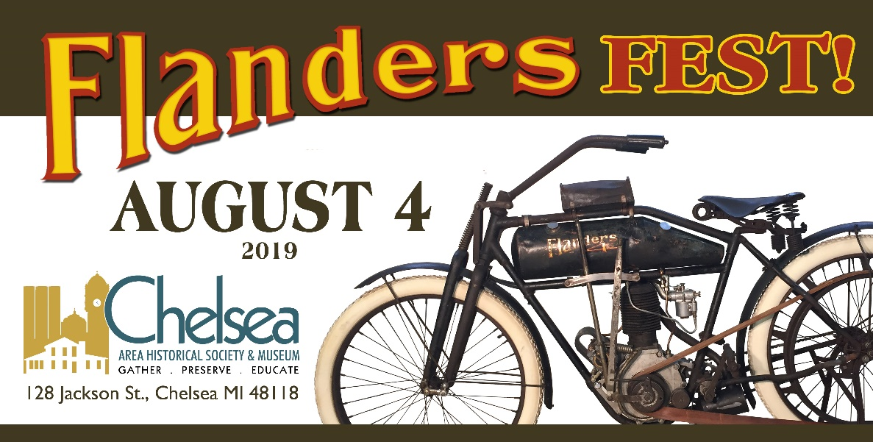

Join us for the 1st Annual Flanders Fest or Farley Flanders Fest as we remember our friends Art Farley & Elliott Andrews and the return of Chelsea’s 1911 Flanders.

A Memorial Ride starts at 10:00 and the Flanders Fest itself starts at noon. Food & drinks will be available and all activities will be based from the historic Chelsea Train Depot & Historical Museum at 125 & 128 Jackson Street. Designated parking will be available for vintage bikes.

*For further details: Staff@ChelseaHistory.org or 734-476-2010*